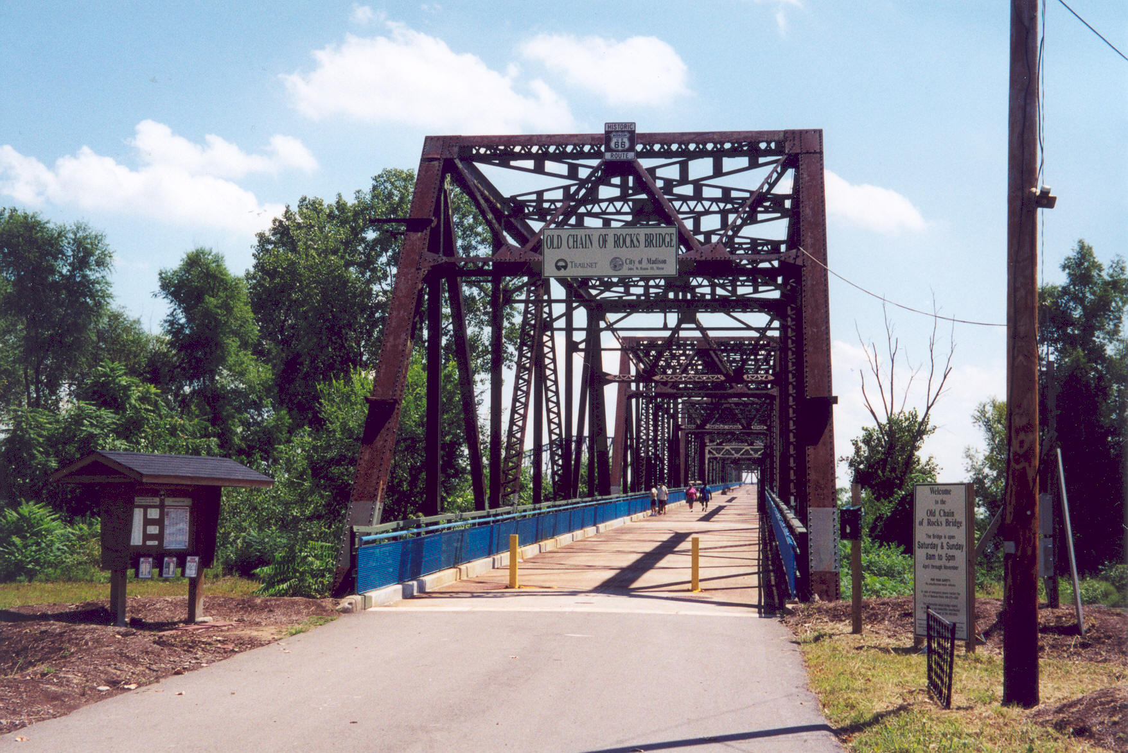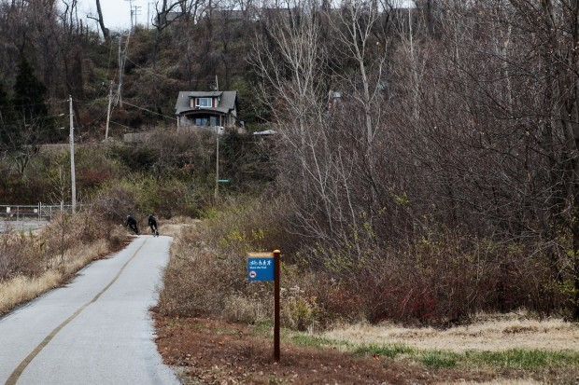
The Old Chain of Rocks Bridge was part of the renowned Route 66
and crosses a scenic stretch of the Mississippi River. It links
two states—Illinois and Missouri—north of St. Louis. The bridge
is short and narrow, only 1 mile long. On the Missouri side, the
Old Chain of Rocks Bridge connects to St. Louis Riverfront Trail.
Chain of Rocks gets its name from the river's rocky shoals south of the bridge. From the bridge deck you'll get stupendous views of the
St. Louis skyline and the Mississippi River. The water-intake towers here rise above the river like half-submerged castle turrets and classic Route 66 memorabilia is displayed on the Missouri side. Interpretive signs tell the Route 66 story and the history of the bridge.
START LOCATION: Chain of Rocks Road on Chouteau Island, Madison, Illinois.
PARKING: At the entrance to Old Chain of Rocks Bridge.
START/FINISH: PLEASE NOTE: One hour start time.
Start between 8 a.m. and 9 a.m. Walk or run at your own pace.
You must be finished by Noon. Event will take place regardless
of the weather. Restrooms available at Missouri side of bridge.
TRAIL: The 5k and 10k trail is rated 1A. Walk is on the Old Chain
of Rocks Bridge and the St. Louis Riverfront Trail. Walks should be
suitable for strollers and wheelchairs.
AWARD: IVV credit is given for the walk.
REGISTRATION: Event is open to the public. Fee is $3 for all walkers. An adult must accompany walkers under age 12. There is
no refund for monies paid.
REFRESHMENTS: Water will be available at start and finish.
SANCTION: Sanctioned by the American Volkssport Association (AVA), a member of the International Federation of Popular Sports (IVV), This event counts toward the acquisition of IVV Achieve- ment Awards. IVV books are available at the start/finish for $6.
PROCEDURE: At the start, get a Start Card and fill it out. Carry
this card with you on the walk. Start Cards remain the property of Lebanon Cedar Cruisers and must be turned in at the finish point
at the end of your walk.
INFORMATION CONTACT: The point of contact is
Bill Malina, 604 Marcia Blvd., New Baden, IL 62265
618-588-4097, wmalina@charter.net.
AVA website is www.ava.org
DISCLAIMER: AVA and the sponsors of this event are not
liable for accidents, thefts or material damages. Every effort will
be made by the sponsors to make this a safe, enjoyable &
memorable event.
SPECIAL PROGRAMS: Border Crossings
Bridges - Spanning the USA
Doin' the Louisiana Purchase Walking the USA A-Z
Walking the United States


DIRECTIONS AND MAP:
From I-270:
Take Exit 3 onto State Rte 3 South/Lewis and Clark Blvd.
At the first stoplight, turn right onto Chain of Rocks Road
and continue 2.2 miles to parking at the end of the road.

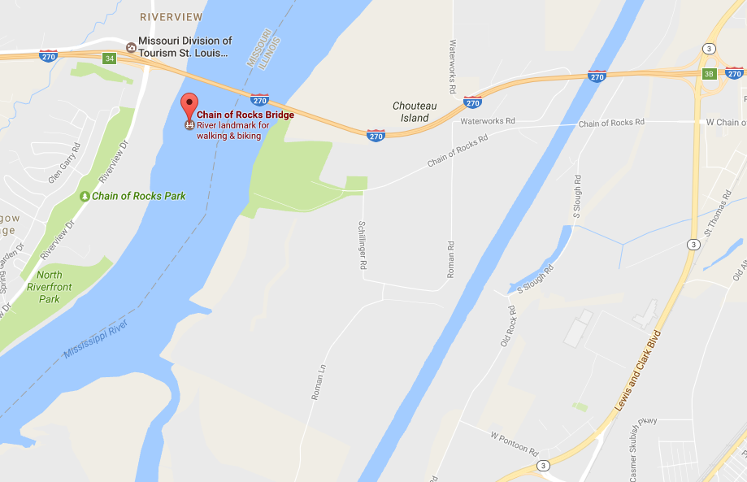

Old Chain of Rocks Bridge
Madison, Illinois to St. Louis, Missouri

A non-competitive 5k & 10k Walk Credit Only
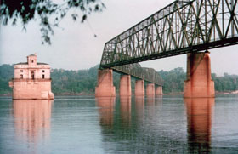
Presented by Lebanon Cedar Cruisers
Celebrating 30 Years in 2017!!!
Saturday, June 24, 2017

AVA Sanction Number MA17-107899


