WELCOME: Walk under the watchful eye of the “Old Tin Man” water tower in Millstadt with the Illinois Trekkers. The “Tin Man” is closely connected with the identity of Millstadt since the 1930s and is one of the few remaining hemispherical bottom and conical roof water towers in Illinois. It is visible from many vantage points while you are on the village walk. In addition, as you walk through town, collect Halloween treats at businesses and services. Most exciting, there will be a Tin Man Costume Contest. Dress up as a Tin Man (the water tower or from the Wizard of Oz!) and you could win a great prize!! Judging will be done by members of the Friends of the Old Millstadt Water Tower. Come join us!
WHAT IS A VOLKSMARCH: A leisurely walk through a scenic, historic, and/or interesting area over a clearly marked trail. The event is a family oriented, noncompetitive walk done at your own pace. An achievement program is available to keep track of your accomplishments.
REGISTRATION LOCATION/TIMES:
Village Park Shelter No. 1, 112 West Gooding
Street, Millstadt, IL 62260. Start: 9:00 –
11:00 AM and Finish by 2:00 PM
SPONSOR: The Illinois Trekkers Volkssport Club, a member of AVA, is a not for profit walking club. The club sponsors weekly, monthly, and year round walks.
TRAIL: A map and directions are provided, with limited trail markings. The two 5k loops are rated 1B. The loops follow paved park paths, nature trails, and village sidewalks and streets.
SANCTION / AWARD: Sanctioned by the American Volkssport Association (AVA), a member of the International Federation of Popular Sports (IVV). Event counts toward the acquisition of IVV Achievement Awards. This is an IVV credit walk only.
DISTANCE: 5K (3.1 miles) walk and 10K (6.2miles) walk.

FEES AND PROCEDURE: $3.00 per participant. AVA regulations specify each person must fill out and sign a start card before beginning the walk. Carry this card with you and personally present it at any checkpoints and at the finish point. All start cards remain the property of Illinois Trekkers and must be turned in at the finish point when the walk is completed.
REGISTRATION / INFORMATION CONTACT: Diane Prost, phone (256)527-3377 or diaprost@sisna.com.
AVA Website: www.ava.org
Illinois Trekkers Website: www.illinois-trekkers.org

STIPULATIONS: This event is open to everyone. Water is available at the registration point. No refunds are given for any monies paid. The event is held regardless of weather conditions.
DISCLAIMER: The Illinois Trekkers Volkssport Club, AVA, or IVV cannot be held liable for any accidents, injury, lost or stolen items, and/or material damage. Every effort will be made by the sponsors to make this a safe, enjoyable, and memorable event.
MISCELLANEOUS: Parking is available at the Start Point in the Park. Pets are welcome but they must be leashed at all times and the owner is responsible for cleanup. Unsuitable for strollers, wheelchairs, and wagons. Restrooms are available at the Start Point.
SPECIAL PROGRAMS:
Ice Cream Parlors
Little Free Libraries
Take a Walk in a City Park
United States Post Offices
Walk the USA Street by Street
Walking the United States
Walking the USA A-Z

DIRECTIONS AND MAP:
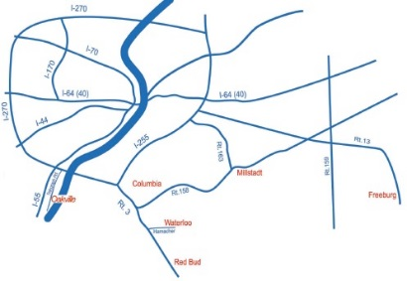
Village Park Shelter No. 1, 112 West
Gooding Street, Millstadt 62260.
NORTH: Take IL 163 South to Millstadt and turn right on W. Gooding St. SOUTH: Take IL 163 North to Millstadt and turn left on W. Gooding St. EAST Take IL 158 to Millstadt. At intersection with IL 163 turn left. Proceed to W. Gooding St. and turn left. WEST: Take IL 158 to Millstadt. At intersection with IL 163 turn right. Proceed to W. Gooding St. and turn left.
GPS COORDINATES: 38.463247 -90.093954

OTHER AREA WALKS: There are over 20 Year-Round-Walks in the Metro Saint Louis area, including four YREs close by in Belleville. Join us in walking for “FUN, FITNESS, FRIENDSHIP.”

“OLD TIN MAN”
WALK &
COSTUME CONTEST
MILLSTADT,
ILLINOIS
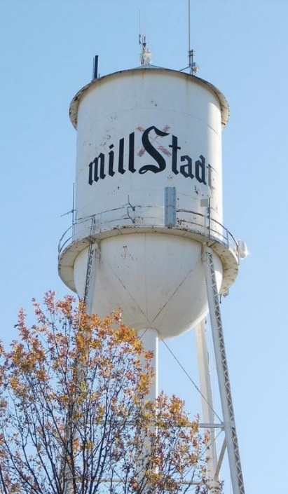
Millstadt “Old Tin Man” Wizard of Oz “Tin Man”
SATURDAY
OCTOBER 26, 2019
Start: 9:00-11:00 AM
Hosted by
ILLINOIS TREKKERS VOLKSSPORT CLUB
AVA SANCTION # MA19/114605

The event is held regardless of weather conditions

