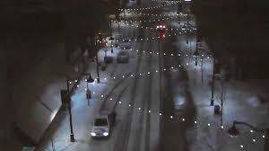

The Illinois Trekkers invite you to walk with us in downtown
Belleville, Illinois on New Year’s Eve 2019. Belleville is French
meaning “beautiful city". Most of the population, however, is of
German heritage. Join us for a walk along Main Street (claimed to
be America's longest continuous Main Street). True or not, it is the
longest in Illinois! We will walk the Downtown part of Main Street
all decked out for the holidays, The Veterans Memorial Fountain on
the Square will be lit and decorated and there will be lights over the
street to brighten the night. Be sure to check out the annual
Gingerbread Contest creations in the store windows.
START LOCATION: Balance Coffee and Tea, 732 South Illinois
Street (Illinois Highway 159), Belleville, Illinois.
START TIME: 4:30 p.m. – 5 p.m.
Please Note: Registration will ONLY be from 4:30 to 5:00 p.m.
FINISH TIME: Must be finished by 7 p.m.
TRAIL: There are two 5k loops, both on city sidewalks and rated 1A.
This is a winter walk so dress accordingly.
A flashlight is recommended since this is a night walk.
AWARD: IVV credit is given for the walk.
REGISTRATION: Everyone is welcome to participate in this event for the fee of $3. An adult must accompany children age 12 & under. All participants must check-in at the Registration Table & receive a start card. There is no refund for monies paid. Pets are welcome, but must be kept on a leash. Pets are not allowed in the coffee shop.
DINNER RESERVATIONS: After the walk we will gather at
at the Tavern on Main at 301 East Main Street, Belleville, Illinois. If you plan to join us for dinner you must make reservations by calling or emailing Trudy Duffman
by Friday, December 27th . Please Note: We will be in the back of the restaurant. The room will be available at 6:30 p.m. for cocktails and dinner at 7 p.m.
INFORMATION CONTACT: Questions and reservations:
Trudy Duffman, 618-670-6920, email trudyduffman@yahoo.com
AVA website is www.ava.org
Illinois Trekkers website is www.illinois-trekkers.org
DISCLAIMER: AVA and the sponsors of this event are not
liable for accidents, thefts or material damages. Every effort will
be made by the sponsors to make this a safe, enjoyable &
memorable event.
MISCELLANEOUS: Refreshments and restrooms are
available at the Start/Finish.
SPECIAL PROGRAMS: Walking the USA A-Z.

Start 2020 by walking many of the YREs (16+)available within immediate Metro-East IL/St. Louis area.

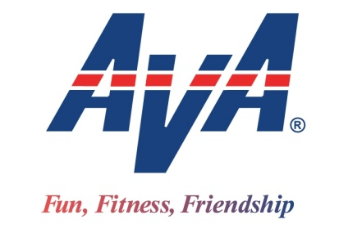
DIRECTIONS AND MAP: I-64 exit 12 (IL-159). Follow IL-159 S. Continue through Swansea to downtown Belleville. After going around Fountain (circle) continue on IL-159S (Illinois Street) to 732 Illinois Street (Train Depot) on left.

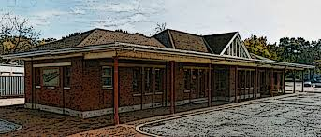
Start Point: Balance Coffee and Tea
732 South Illinois Street
Belleville, Illinois
Thank you for being there for the Illinois Trekkers

New Year’s Eve Walk
& Dinner
A non-competitive 5k & 10k Walk Credit Only
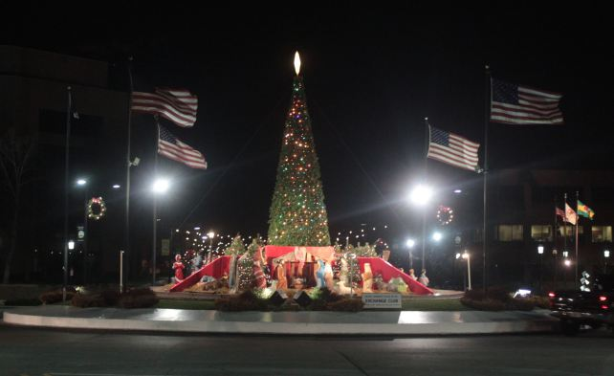
Presented by Illinois Trekkers
Tuesday, December 31, 2019
AVA Sanction Number MA19-116113

