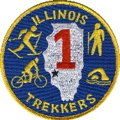

Illinois Trekkers: We like to Walk, Talk, Sight See and on Occasion Stop for Food. We would like for YOU to Join Us!!

AVA Vision: Increasingly engage Americans in lifelong walking and other non- competitive physical fitness activities.

AVA Mission: Promote and organize noncompetitive fitness activities that encourage lifelong fun, fitness and friendship for all ages and abilities.

Walking for the Fun of It.

llinois-Trekkers.org
njwilcoxen@aol.com OR susanljones52@gmail.com

National Walk Week  Illinois Trekkers  PO Box 603  O’Fallon, IL 62269 | 618-973-3825 leave message
National Walk Week April 1-7, 2021

Illinois Trekkers

